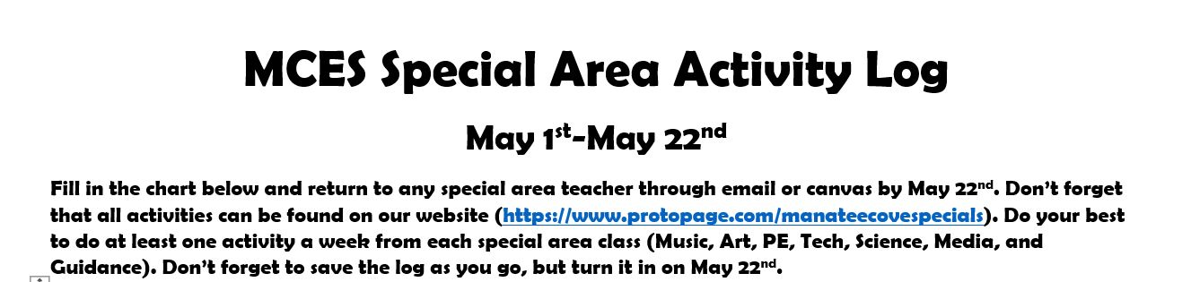

Student Name: | Classroom Teacher:
Example:
Date | Subject  (Music, Art, PE, Tech, Science, Media, Guidance) | Activity  (What did you do?) | Time  (How many minutes did you do the activity?)
5/4/2020 | PE | Cupstacking Videos | 15 minutes

